Project Design Phase-II
Data Flow Diagram & User Stories

Date | 20 February 2025
Team ID | LTVIP2026TMIDS34731
Project Name | HouseHunt-Finding Your Prefect Rental Home
Maximum Marks | 4 Marks

Data Flow Diagrams:
A Data Flow Diagram (DFD) is a traditional visual representation of the information flows within a system. A neat and clear DFD can depict the right amount of the system requirement graphically. It shows how data enters and leaves the system, what changes the information, and where data is stored.
Example: DFD Level 0 (Industry Standard)
Example: (Simplified)
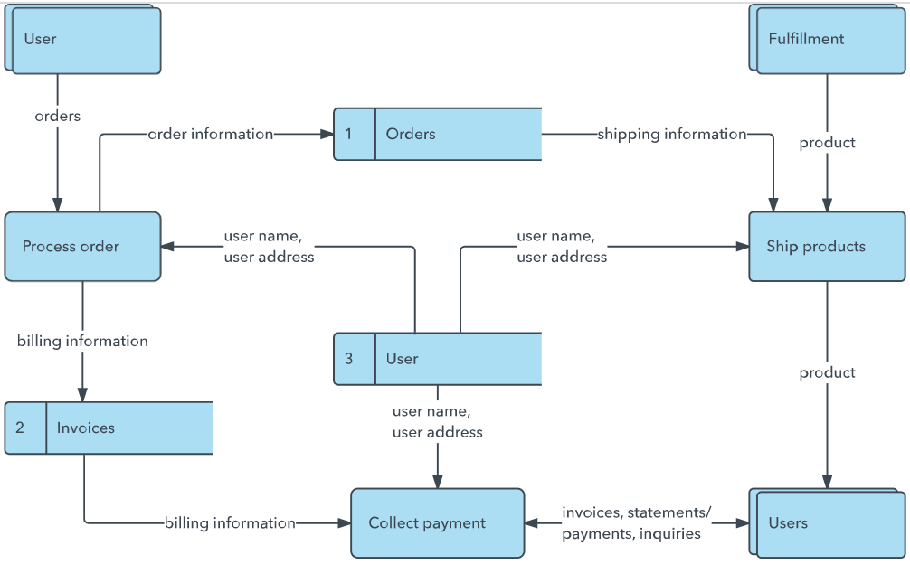


User Stories
Use the below template to list all the user stories for the product.
User Type | Functional Requirement (Epic) | User Story Number | User Story / Task | Acceptance criteria | Priority | Release
Renter | Registration & Login | USN-1 | As a renter, I can create an account and log in securely. | User is redirected to the dashboard with an Auth token stored. | High | Sprint-1
Renter | Property Discovery | USN-2 | As a renter, I can filter properties by location, BHK, and price. | Filtered property list is displayed in real-time. | High | Sprint-2
Renter | Property Inquiry | USN-3 | As a renter, I can send my details to an owner for a property I like. | Inquiry appears in the user's booking section as "Pending". | High | Sprint-2
Owner | Property Management | USN-4 | As an owner, I can add, edit, and delete my property listings. | CRUD operations update the property database immediately. | High | Sprint-3
Owner | Booking Approval | USN-5 | As an owner, I can approve or confirm a renter's booking request. | Renter receives a notification and status changes to "Confirmed". | Medium | Sprint-3
Admin | Platform Governance | USN-6 | As an admin, I can approve owner accounts and monitor activity. | Only approved owners can post active property listings. | Medium | Sprint-4

